GliGli’s Overcycler
Affordable polyphonic hybrid single cycle / analog synthesizer.

Table of Contents
Introduction 3
Overview 4
1 Features 4
2 Front panel 5
3 Rear panel 6
4 Basic ergonomics 7
The pages 9
1 Oscillators 9
2 WaveMod 10
3 Filter 11
4 Amplifier 12
5 LFO 1 13
6 LFO 2 14
7 Arpeggiator 15
8 Sequencer 16
9 Miscellaneous 17
10 Presets 19
Maintenance 21
1 Adding single-cycle waveforms 21
2 Data backup 21
3 Upgrading the firmware 21
MIDI implementation 22
1 Chart 22
2 Detailed continuous controllers 23
3 Continuous NRPN parameters list 26
4 Stepped NRPN parameters list 28

Introduction

This project started about 10 years ago, when I wanted to make use of spare SSM2044 voltage controlled low pass filters I had laying around.
It went through 3 major revisions until it became the full-fledged retail synthesizer it is now.
There is 2 versions of this synthesizer, “Fully built” and “DIY”. This manual is about operating the synthesizer for both. Build instructions for the “DIY” version will be available in another document.

Overview

Features
- 6 voice polyphony using hybrid synthesis (Digital “single cycle” oscillators / per-voice analog voltage-controlled filter and voltage-controlled amplifier).
- 2 synchronizable oscillators per voice, duty cycle modulation on any waveform, dual waveform mix modulation, “grith” modulation (from a subtle veil to “ring modulation”-like sounds), 64KHz sample rate for a clean sound by default.
- 3 complete envelopes with linear/exponential choice and looping (oscillators / filter / amplifier).
- 2 complete low frequency oscillators with 6 modulation destinations.
- 1 noise generator.
- Voice panning on the stereo output.
- Sequencer / Arpeggiator.
- Patches and single cycles (AKWF, ProphetVS,...) stored on an internal flash chip, accessible through USB mass storage.
- USB powered with USB MIDI and regular MIDI, Ccs for coarse values, NRPN, channel after-touch,...

Front panel

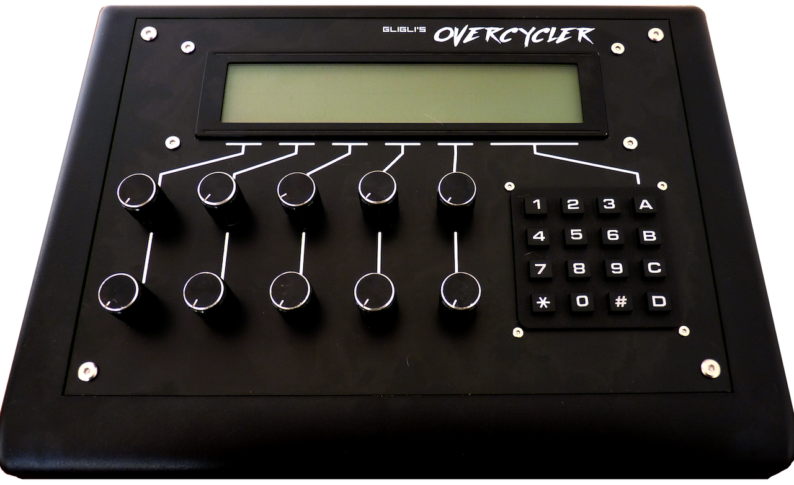
①
②
③
① Back-lit character LCD screen, 4 rows of 40 characters.
② 10 potentiometers, in 2 rows of 5.
③ Keypad, 4 rows of 4 keys.

Rear panel

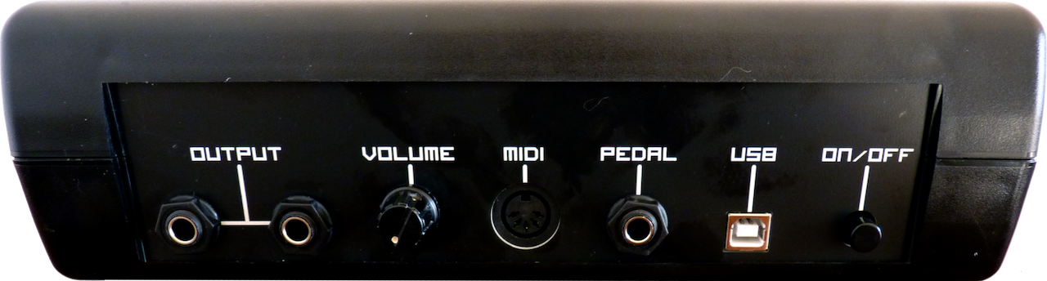
① Main output 6,35mm jacks.
①
②
③
④
⑤
⑥
- Connect a single jack to get TRS (tip-ring-sleeve) stereo (eg. headphones).
- Connect 2 jacks to get TS (tip-sleeve) left and right stereo (eg. connect to 2 mono channels on a mixer).
Note: As synthesizer voices are hard-panned on the stereo output, it is recommended to connect to a mixer through 2 mono channels, that way mixer channel panning can be used to moderate the stereo effect (by setting channel panning symmetrically from the center).
② Main volume knob, from low volume (left) to high volume (right).
③ DIN MIDI input.
④ Pedal (aka. foot switch) 6,35mm TS input jack, “press to connect” configuration.
- Acts as a sustain input when not arpeggiating or in unison mode.
- Holds the arpeggiator pattern when arpeggiating (has priority over sustain).
- Sets a chord pattern when in unison mode (has priority over sustain and arpeggiator hold).
⑤ USB-B input, power input for the synthesizer. It can also be used for USB MIDI and for internal disk access through USB mass storage.
⑥ Synthesizer on / off switch, pressed is on.

Basic ergonomics

Basically, ergonomics are centered around the use of the screen, mainly to show potentiometers and buttons values for the current page of parameters.

The main screen
③
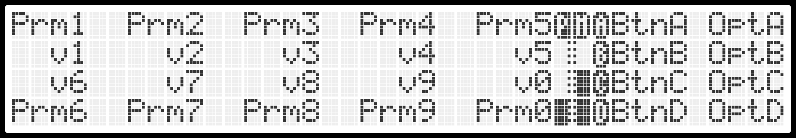
①
②
④
① 2 rows of 5 parameters, one for each potentiometer from the front panel. Each parameter has a short name on 4 characters and a value. Turning a potentiometer will allow changing the corresponding parameter value through the “Potentiometer edit screen”.
② 4 rows of parameters, corresponding to the rightmost (A / B / C / D) buttons of the keypad. Pressing one of those keypad keys will allow changing the corresponding parameter to a new value through the “Button edit screen”.
③ ”Preset modified” indicator. Changing any parameter from the current preset will show this indicator as a remainder that changes many need to be saved to persist.
④ .”Voice activity” indicators. One for each of the 6 voices, giving an overview of the amplifier envelope state for each voice. The layout is as follows:
Voice 1 | Voice 2
Voice 3 | Voice 4
Voice 5 | Voice 6

The potentiometer edit screen
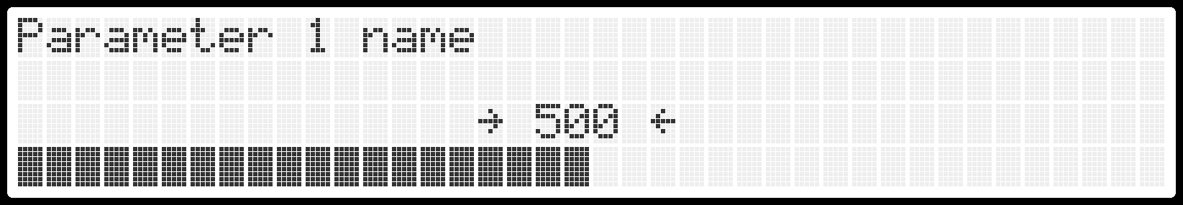
When a potentiometer is turned, this screen shows detailed information about the parameter being edited:
- The parameter long name at the top.
- The current parameter value in the middle.
- A bar-graph showing the approximate value at a glance.
When the current potentiometer position is out of range, and the value hasn’t been reacquired (that is, the potentiometer is still locked to its previous value), the screen will show one of two arrows around the numerical value to hint which way it should be turned.
Note: when more than one potentiometer is turned at the same time, this screen will not show. Instead, the main screen will directly reflect the changes.

The button edit screen
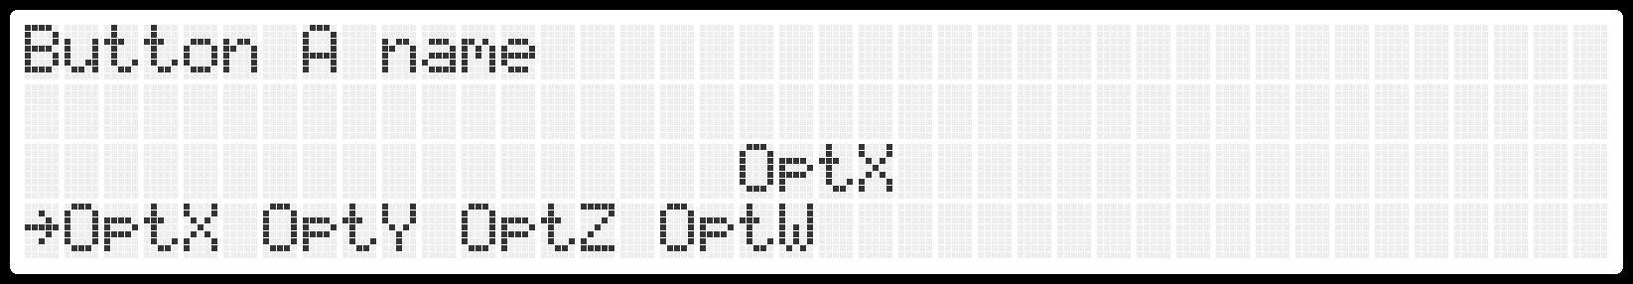

When a button (A / B /C / D) is pressed, this screen shows detailed information about the parameter being edited:
- The parameter long name at the top.
- The current parameter value in the middle.
- A list of all the possible values for the parameter, with an arrow indicating which is currently chosen.
Note: some buttons are used for actions, in that case the action is performed as soon as the button is pressed and this screen only shows the action long name.

The pages

Oscillators
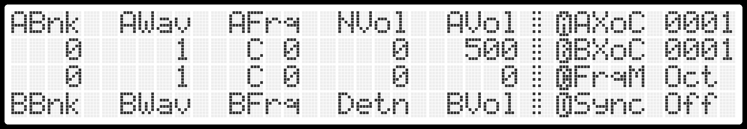
- ABnk / BBnk: Oscillator A / B Single-cycle bank.
- AWav / BWav: Oscillator A / B Single-cycle waveform. Note: Waveforms are displayed on the screen while they are chosen.
- AFrq / BFrq: Oscillator A / B base frequency. Note: The "FrqM" parameter can be used to change the granularity.
- Detn: Oscillator A / B relative detune. Note: This parameter will slightly change both oscillators pitch, to ensure the overall tuning stays the same.
- NVol / AVol / BVol: Oscillator A / B and noise generator volume. Note: When the sum of these 3 volumes exceeds 1000, a strong but pleasing overdrive will be heard.
- AXoC / BXoC: Copy A / B bank/wave to A / B Crossover. Note: The "Crossover" WaveMod has to be chosen for these parameters to have an effect.
- FrqM: Granularity for AFrq and BFrq, either in octaves, in semitones, or freeform.
- Sync: Oscillator A to B Synchronization. Note: Try the "Frequency" WaveMod on oscillator B to get typical sounds.

WaveMod
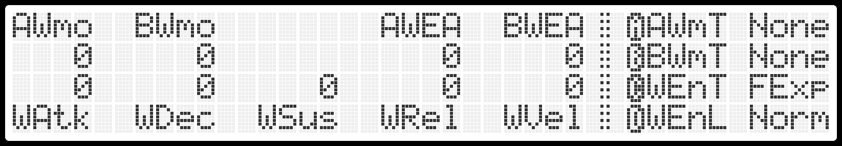
- AWmo / BWmo: Base amount of WaveMod for oscillator A / B.
- AWEA / BWEA: WaveMod Envelope Amount for oscillator A / B.
- WAtk / WDec / WSus / WRel / WVel: Attack time / decay time / sustain level / release time / velocity amount for the WaveMod ADSR envelope.
- AWmT / BWmT: WaveMod Type for oscillator A / B, available options:
  - None: No WaveMod.
  - Grit: Simulates low resolution relative to time. A positive amount gives a subtle veil, while a negative amount is wilder and can sound like ring-mod.
  - Width: Applies duty cycle modulation akin to “Pulse Width Modulation” but for any waveform.
  - Frequency: Frequency modulation. Note: especially useful for drum sounds or typical Sync sounds.
  - Crossover: Allows mixing 2 single cycle waveforms, controls the mix of both. Note: use the buttons "AXoC" and "BXoC" from the Oscillators page to allow setting the second waveform for each oscillator.
- WEnT: WaveMod Envelope Type, available options:
  - Fast-exponential.
  - Slow-exponential.
  - Fast-linear.
  - Slow-linear.
- WEnL: WaveMod Envelope Loop. Note: When looped, a cycle of attack / decay happens in what is left of the sustain level. Eg. at full sustain, no looping can be heard.

Filter
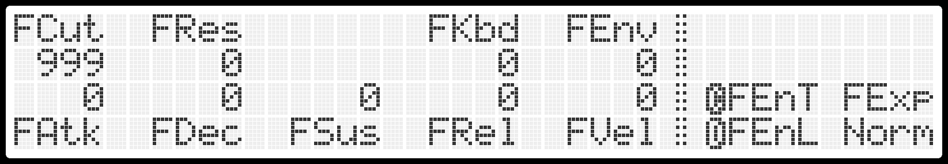
- FCut: Filter Cutoff frequency. Note: The filter is tuned in C, so setting it to eg. 500 will allow to play the filter like an oscillator as long as the Resonance parameter is high enough.
- FRes: Filter Resonance. Note: Self-oscillation can be heard in the last third of amount.
- FKbd: Filter Keyboard tracking. From 0 to 100%, relative to C5 on the keyboard.
- FEnv: Filter Envelope amount.
- FAtk / FDec / FSus / FRel / FVel: Attack time / decay time / sustain level / release time / velocity amount for the filter ADSR envelope.
- FEnT: Filter Envelope Type, available options:
  - Fast-exponential.
  - Slow-exponential.
  - Fast-linear.
  - Slow-linear.
- FEnL: Filter Envelope Loop. Note: When looped, a cycle of attack / decay happens in what is left of the sustain level. Eg. at full sustain, no looping can be heard.

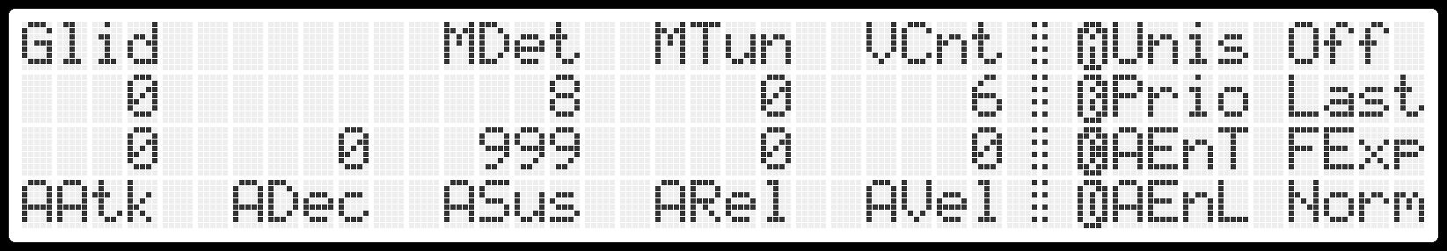
Amplifier

- Glid: Glide amount. This acts as a slew limiter on the oscillators pitch.
- MDet: Master unison Detune. This spreads voice tuning. Note: A small amount can simulate the non-exactness of an analog oscillator.
- MTun: Master Tune. Note: default tuning is A=440Hz.
- VCnt: Voice count.
- Unis: Unison mode (all voices playing for a single key press). Note: If a chord is pressed while activating this option, this works as "chord mode". The pedal input can be used to latch a new chord.
- Prio: Assigner Priority mode, available options:
  - Last: the last played note (relative to time) has priority.
  - Low: the lowest played note (relative to pitch) has priority.
  - High: the highest played note (relative to pitch) has priority.
- AAtk / ADec / ASus / ARel /AVel: Attack time / decay time / sustain level / release time / velocity amount for the amplifier ADSR envelope.
- AEnT: Amplifier Envelope Type, available options:
  - Fast-exponential.
  - Slow-exponential.
  - Fast-linear.
  - Slow-linear.
- AEnL: Amplifier Envelope Loop. Note: When looped, a cycle of attack / decay happens in what is left of the sustain level. Eg. at full sustain, no looping can be heard.

LFO 1
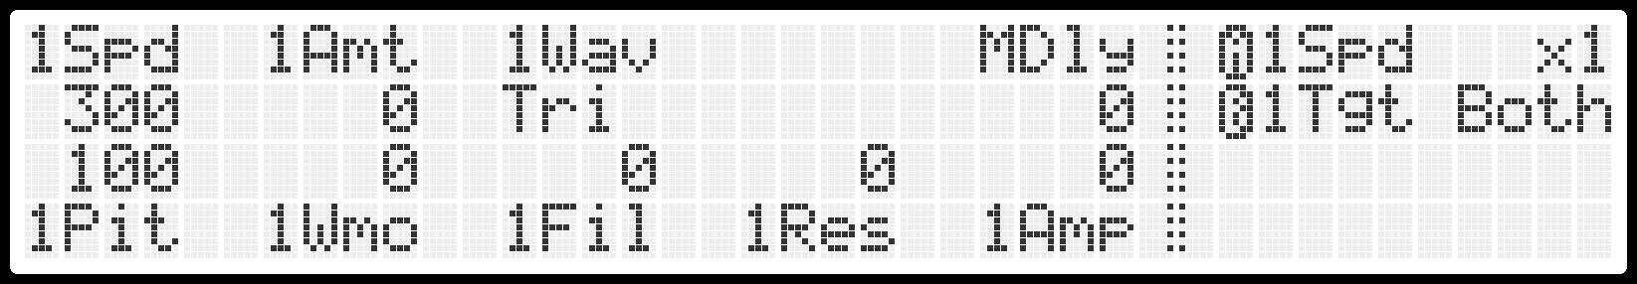
- 1Spd: LFO1 speed in BPM (Beats Per Minute), can be multiplied by 1x to 8x using the corresponding button.
- 1Amt: Base amount of modulation for LFO1. Note: Mod-wheel amount is added to this if parameter "MTgt" on the Miscellaneous page is set to LFO1.
- 1Wav: Waveform of LFO1, available options:
  - Square.
  - Triangle.
  - Random (sample and hold).
  - Noise. Note: richness of the noise can be controlled by the "1Spd" parameter.
  - Sawtooth.
  - Reversed sawtooth.
- MDly: Modulation delay, applied to the other LFO from parameter "MTgt" on the Miscellaneous page.
- 1Tgt: LFO1 Oscillator Target, available options:
  - None: No oscillator will be affected by LFO1.
  - OscA: Only oscillator A will be affected by LFO1.
  - OscB: Only oscillator B will be affected by LFO1.
  - Both: Both oscillators will be affected by LFO1.
- 1Pit / 1Wmo / 1Fil / 1Res / 1Amp: Amount of modulation from LFO1 going to Oscillators pitch / Oscillators WaveMod / Filter Cutoff / Filter Resonance / Amplifier.

LFO 2
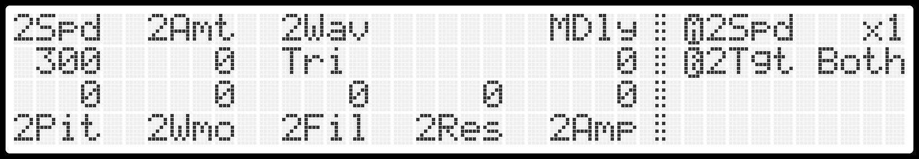
- 2Spd: LFO2 speed in BPM (Beats Per Minute), can be multiplied by 1x to 8x using the corresponding button.
- 2Amt: Base amount of modulation for LFO2. Note: Mod-wheel amount is added to this if parameter "MTgt" on the Miscellaneous page is set to LFO2.
- 2Wav: Waveform of LFO2, available options:
  - Square.
  - Triangle.
  - Random (sample and hold).
  - Noise. Note: richness of the noise can be controlled by the "2Spd" parameter.
  - Sawtooth.
  - Reversed sawtooth.
- MDly: Modulation delay, applied to the other LFO from parameter "MTgt" on the Miscellaneous page.
- 2Tgt: LFO2 Oscillator Target, available options:
  - None: No oscillator will be affected by LFO2.
  - OscA: Only oscillator A will be affected by LFO2.
  - OscB: Only oscillator B will be affected by LFO2.
  - Both: Both oscillators will be affected by LFO2.
- 2Pit / 2Wmo / 2Fil / 2Res / 2Amp: Amount of modulation from LFO2 going to Oscillators pitch / Oscillators WaveMod / Filter Cutoff / Filter Resonance / Amplifier.

Arpeggiator
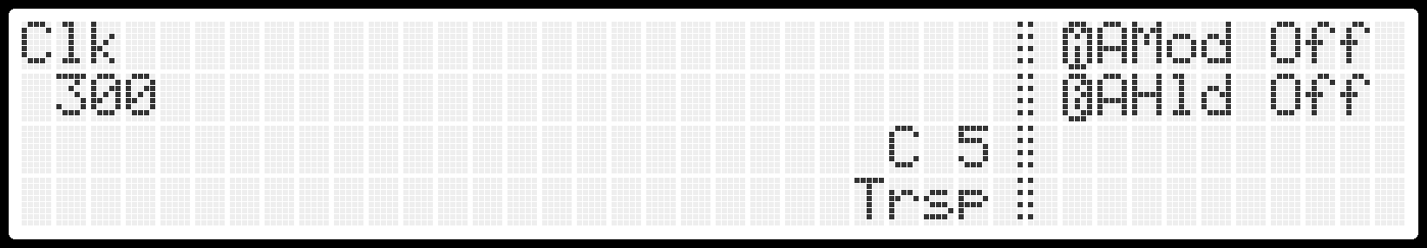
- Clk: Sequencer / Arpeggiator clock. Either expressed in BPM (Beats Per Minute) when the "Sync" parameter from the Miscellaneous page is set to internal, or in MIDI clock divisor when it is set to MIDI or USB.
- Trsp: Keyboard transpose from C5. Note: the (#) button can always be used to transpose the arpeggiator or sequencer on the fly.
- AMod: Arpeggiator Mode, available options:
  - Off: Arpeggiator is deactivated.
  - UpDn: Arpeggiator works in Up / Down mode, not repeating the highest and lowest notes.
  - Rand: Arpeggiator works in Random mode, never repeating the same note twice.
  - Asgn: Arpeggiator works in Assign mode, playing notes in the order they were pressed.
- AHld: Arpeggiator Hold. Pressing this button will maintain the current arpeggio pattern, only allowing new notes in. Note: The pedal input controls this parameter when the arpeggiator mode is not Off and Unison is not active.

Sequencer
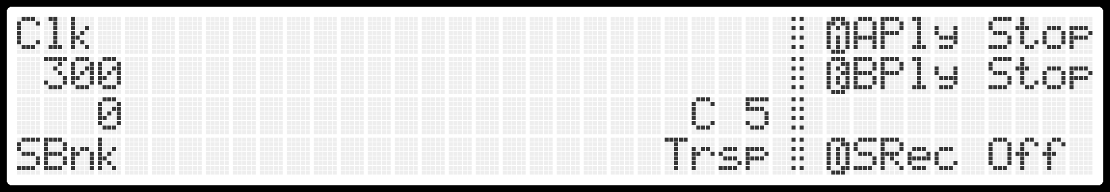
- Clk: Sequencer / Arpeggiator clock. Either expressed in BPM (Beats Per Minute) when the "Sync" parameter from the Miscellaneous page is set to internal, or in MIDI clock divisor when it is set to MIDI or USB.
- Trsp: Keyboard transpose from C5. Note: the (#) button can always be used to transpose the arpeggiator or sequencer on the fly.
- SBnk: Sequencer memory Bank. One of 20 banks of 2 sequences (A and B) can be chosen.
- APly / BPly: Play / Stop button for Sequences A and B.
- SRec: Sequence record, available options:
  - Off: No sequence is recording.
  - SeqA: Sequence A is recording.
  - SeqB: Sequence B is recording.

Note: When recording a sequence, buttons A / B / C correspond to the following actions:
- (A) TiRe: Add a Tie or a Rest to the sequence. If a keyboard note is pressed, then it will add a Tie with this note, else it will add a Rest.
- (B) Back: Back one step in the sequencer, erasing the current step.
- (C) Clr: Erases the entire sequence.

Miscellaneous
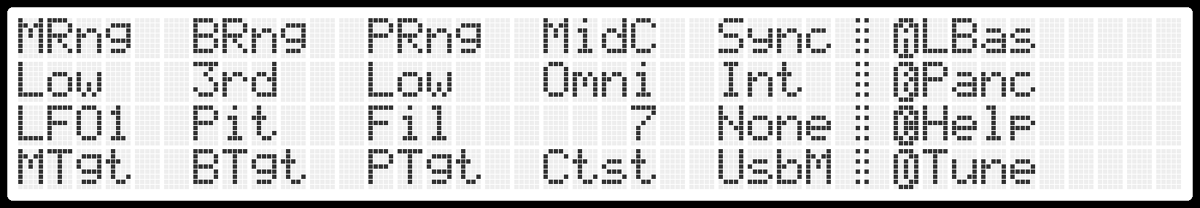
- MRng: Mod-wheel Range, from "Min" to "Full".
- MTgt: Mod-wheel Target, either LFO1 or LFO2. Note: The other LFO is controlled by the "MDly" parameter from page LFO 1 or LFO 2.
- BRng: Pitch bender range, either a major third, a fifth or an octave up and down.
- BTgt: Pitch bender target, available options:
  - None: Nothing is affected by the pitch bender.
  - Pit: Pitch bender targets oscillators pitch.
  - Fil: Pitch bender targets filter cutoff frequency.
  - Vol: Pitch bender targets oscillators volume.
  - XOvr: Pitch bender targets oscillators "Crossover" WaveMod mix.
- PRng: Channel pressure range, from "Min" to "Full".
- PTgt: Channel pressure target, available options:
  - None: Nothing is affected by channel pressure.
  - Pit: Channel pressure targets oscillators pitch.
  - Fil: Channel pressure targets filter cutoff frequency.
  - Vol: Channel pressure targets oscillators volume.
  - XOvr: Channel pressure targets oscillators "Crossover" WaveMod mix.
  - LFO1: Channel pressure targets LFO1 amount.
  - LFO2: Channel pressure targets LFO2 amount.

- MidC: Input MIDI channel, either "Omni" or 1-16. Note: also affects USB MIDI.
- Ctst: Screen contrast, from 0 (dim) to 10 (strong).
- Sync: Synchronization source for arpeggiator and sequencer, either "Internal", "MIDI", or "USB" (USB MIDI).
- UsbM: USB mode, available options:
  - None: USB cable only acts as a power source.
  - Disk: USB is in "Mass Storage" mode, this mode is blocking and can be quit by pressing a keypad button. Warning: be sure to eject the corresponding drive before quitting this mode while connected to a computer!
  - MIDI: USB is in "MIDI" mode. Note: parameter "MidC" also affects USB MIDI channel.
- LBas: Loads a basic (plain sawtooth) patch. Note: if the current preset was modified beforehand, a warning will be displayed and the button will have to be pressed again to take effect.
- Panc: MIDI Panic, all voices are immediately silenced and assigner restarts at voice 1.
- Help: Returns to the startup page.
- Tune: Runs the voices filters tuning procedure. Note: this can take a while, progress will be displayed while running.

Presets
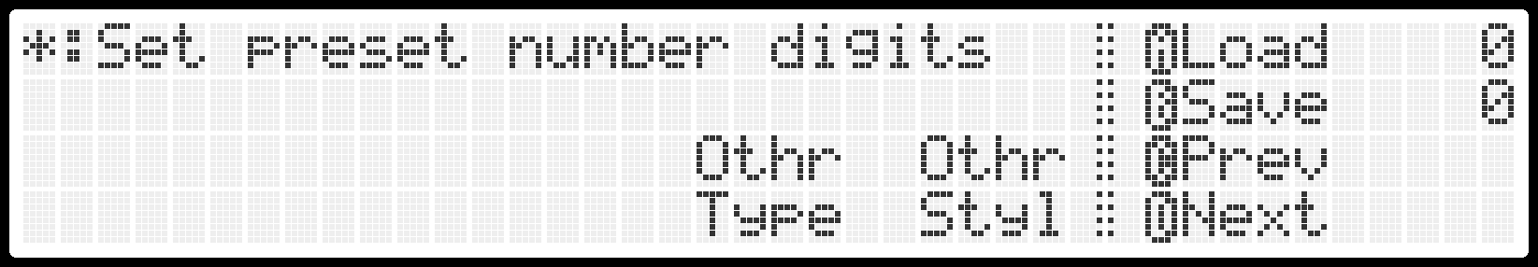
- Load: Loads the current preset from the preset number that is active. Note: if the current preset was modified beforehand, a warning will be displayed and the button will have to be pressed again to take effect.
- Save: Saves the current preset to the preset number that is active. Note: if a preset with that number already exists, a warning will be displayed and the button will have to be pressed again to take effect.
- Prev: Loads the previous preset number. Note: if the current preset was modified beforehand, a warning will be displayed and the button will have to be pressed again to take effect.
- Next: Loads the next preset number. Note: if the current preset was modified beforehand, a warning will be displayed and the button will have to be pressed again to take effect.
Note: pressing the (*) button allows selecting the 3 digits preset number, as there are 1000 possible presets. Pressing the (*) button again cancels preset number selection.

- Type: Basic type of instrument for the preset (informative only), available options:
  - Other.
  - Bass.
  - Pad.
  - Strings.
  - Brass.
  - Keys.
  - Lead.
  - Arpeggios.
- Style: Basic style of sound for the preset (informative only), available options:
  - Other.
  - Neutral.
  - Clean.
  - Real.
  - Silky.
  - Raw.
  - Heavy.
  - Crunchy.

Maintenance

Adding single-cycle waveforms

Data backup

Upgrading the firmware

MIDI implementation

Chart

Function |  | Transmitted | Recognized | Remarks
Basic Channel | Default  Changed | ✗  ✗ | 1 – 16  ✓ | See Miscellaneous
Mode | Default  Messages  Altered | ✗  ✗  ✗ | 1  ✗  ✓ | See Amplifier
Note Number | True Voice | ✗  ✗ | 0-127  0-120
Velocity | Note On  Note Off | ✗  ✗ | ✓  ✗ | See Amplifier,  Filter, WaveMod
After Touch | Key  Channel | ✗  ✗ | ✗  ✓ | See Miscellaneous
Pitch Bend |  | ✗ | ✓ | See Miscellaneous
Control Change |  | ✗ | ✓ | See Detailed continuous controllers
Program Change | True # | ✗  ✗ | ✓  0-99 | See Presets
System Exclusive |  | ✗ | ✗
System  Common | Song position  Song select  Tune request | ✗  ✗  ✗ | ✗  ✗  ✗
System Real Time | Clock  Start  Continue  Stop | ✗  ✗  ✗  ✗ | ✓  ✓  ✓  ✓ | See Arpeggiator,  Sequencer,  Miscellaneous
Aux Messages | All Sound Off  Reset Controllers  Local On/Off  All Notes Off  Omni Mode Off  Omni Mode On  Mono Mode On  Poly Mode On  Active Sensing  System Reset | ✗  ✗  ✗  ✗  ✗  ✗  ✗  ✗  ✗  ✗ | ✓  ✗  ✗  ✓  ✗  ✗  ✗  ✗  ✗  ✗

Detailed continuous controllers

Number | Type | Parameter
0 | Standard | Preset bank coarse
1 | Standard | Modulation wheel
2
3
4
5
6 | Standard | NRPN Data Coarse
7
8
9
10
11
12 | Continuous Coarse | cpAFreq
13 | Continuous Coarse | cpAVol
14 | Continuous Coarse | cpABaseWMod
15 | Continuous Coarse | cpBFreq
16 | Continuous Coarse | cpBVol
17 | Continuous Coarse | cpBBaseWMod
18 | Continuous Coarse | cpDetune
19 | Continuous Coarse | cpCutoff
20 | Continuous Coarse | cpResonance
21 | Continuous Coarse | cpFilEnvAmt
22 | Continuous Coarse | cpFilKbdAmt
23 | Continuous Coarse | cpWModAEnv
24 | Continuous Coarse | cpFilAtt
25 | Continuous Coarse | cpFilDec
26 | Continuous Coarse | cpFilSus
27 | Continuous Coarse | cpFilRel
28 | Continuous Coarse | cpAmpAtt
29 | Continuous Coarse | cpAmpDec
30 | Continuous Coarse | cpAmpSus
31 | Continuous Coarse | cpAmpRel
32 | Standard | Preset bank fine
33
34
35
36
37
38 | Standard | NRPN Data Fine
39
40
41 | Stepped | spLFO2Speed
42
43
44 | Continuous Coarse | cpLFOFreq
45 | Continuous Coarse | cpLFOAmt
46 | Continuous Coarse | cpLFOPitchAmt
47 | Continuous Coarse | cpLFOWModAmt
48 | Continuous Coarse | cpLFOFilAmt
49 | Continuous Coarse | cpLFOAmpAmt
50 | Continuous Coarse | cpLFO2Freq
51 | Continuous Coarse | cpLFO2Amt
52 | Continuous Coarse | cpModDelay
53 | Continuous Coarse | cpGlide
54 | Continuous Coarse | cpAmpVelocity
55 | Continuous Coarse | cpFilVelocity
56 | Continuous Coarse | cpMasterTune
57 | Continuous Coarse | cpUnisonDetune
58 | Continuous Coarse | cpNoiseVol
59 | Continuous Coarse | cpLFO2PitchAmt
60 | Continuous Coarse | cpLFO2WModAmt
61 | Continuous Coarse | cpLFO2FilAmt
62 | Continuous Coarse | cpLFO2AmpAmt
63 | Continuous Coarse | cpLFOResAmt
64 | Standard | Hold Pedal
65
66
67
68
69
70 | Continuous Coarse | cpLFO2ResAmt
71 | Continuous Coarse | cpWModAtt
72 | Continuous Coarse | cpWModDec
73 | Continuous Coarse | cpWModSus
74 | Continuous Coarse | cpWModRel
75 | Continuous Coarse | cpWModBEnv
76 | Continuous Coarse | cpWModVelocity
77
78
79
80 | Stepped | spLFOSpeed
81 | Stepped | spABank
82 | Stepped | spAWave
83 | Stepped | spAWModType
84 | Stepped | spBBank
85 | Stepped | spBWave
86 | Stepped | spBWModType
87 | Stepped | spLFOShape
88 | Stepped | spLFOTargets
89 | Stepped | spFilEnvSlow
90 | Stepped | spAmpEnvSlow
91 | Stepped | spBenderRange
92 | Stepped | spBenderTarget
93 | Stepped | spModwheelRange
94 | Stepped | spModwheelTarget
95 | Stepped | spUnison
96 | Standard | spAssignerPriority
97 | Standard | spChromaticPitch
98 | Standard | spOscSync
99 | Standard | NRPN Number Coarse
100
101
102 | Stepped | spAXOvrBank
103 | Stepped | spAXOvrWave
104 | Stepped | spFilEnvLin
105 | Stepped | spLFO2Shape
106 | Stepped | spLFO2Targets
107 | Stepped | spVoiceCount
108 | Stepped | spPresetType
109 | Stepped | spPresetStyle
110 | Stepped | spAmpEnvLin
111 | Stepped | spFilEnvLoop
112 | Stepped | spAmpEnvLoop
113 | Stepped | spWModEnvSlow
114 | Stepped | spWModEnvLin
115 | Stepped | spWModEnvLoop
116 | Stepped | spPressureRange
117 | Stepped | spPressureTarget
118 | Stepped | spBXOvrBank
119 | Stepped | spBXOvrWave
120 | Standard | All sounds off
121
122
123 | Standard | All notes off
124
125
126
127

Continuous NRPN parameters list

Coarse number | Fine number | Parameter | Zero centered?
0 | 0 | cpAFreq | -
0 | 1 | cpAVol | -
0 | 2 | cpABaseWMod | Yes
0 | 3 | cpBFreq | -
0 | 4 | cpBVol | -
0 | 5 | cpBBaseWMod | Yes
0 | 6 | cpDetune | Yes
0 | 7 | cpCutoff | -
0 | 8 | cpResonance | -
0 | 9 | cpFilEnvAmt | Yes
0 | 10 | cpFilKbdAmt | -
0 | 11 | cpWModAEnv | Yes
0 | 12 | cpFilAtt | -
0 | 13 | cpFilDec | -
0 | 14 | cpFilSus | -
0 | 15 | cpFilRel | -
0 | 16 | cpAmpAtt | -
0 | 17 | cpAmpDec | -
0 | 18 | cpAmpSus | -
0 | 19 | cpAmpRel | -
0 | 20 | cpLFOFreq | -
0 | 21 | cpLFOAmt | -
0 | 22 | cpLFOPitchAmt | -
0 | 23 | cpLFOWModAmt | -
0 | 24 | cpLFOFilAmt | -
0 | 25 | cpLFOAmpAmt | -
0 | 26 | cpLFO2Freq | -
0 | 27 | cpLFO2Amt | -
0 | 28 | cpModDelay | -
0 | 29 | cpGlide | -
0 | 30 | cpAmpVelocity | -
0 | 31 | cpFilVelocity | -
0 | 32 | cpMasterTune | Yes
0 | 33 | cpUnisonDetune | -
0 | 34 |  | -
0 | 35 |  | -
0 | 36 |  | -
0 | 37 | cpNoiseVol | -
0 | 38 | cpLFO2PitchAmt | -
0 | 39 | cpLFO2WModAmt | -
0 | 40 | cpLFO2FilAmt | -
0 | 41 | cpLFO2AmpAmt | -
0 | 42 | cpLFOResAmt | -
0 | 43 | cpLFO2ResAmt | -
0 | 44 | cpWModAtt | -
0 | 45 | cpWModDec | -
0 | 46 | cpWModSus | -
0 | 47 | cpWModRel | -
0 | 48 | cpWModBEnv | Yes
0 | 49 | cpWModVelocity | -

Stepped NRPN parameters list

Coarse number | Fine number | Parameter | Number of steps
1 | 0 |  | -
1 | 1 |  | -
1 | 2 | spABaseWMod | 5
1 | 3 |  | -
1 | 4 |  | -
1 | 5 |  | --
1 | 6 | spBBaseWMod | 5
1 | 7 |  | -
1 | 8 | spLFOShape | 7
1 | 9 | spLFOSpeed | 4
1 | 10 | spLFOTargets | 4
1 | 11 | spFilEnvSlow | 2
1 | 12 | spAmpEnvSlow | 2
1 | 13 | spBenderRange | 3
1 | 14 | spBenderTarget | 5
1 | 15 | spModwheelRange | 4
1 | 16 | spModwheelTarget | 2
1 | 17 | spUnison | 2
1 | 18 | spAssignerPriority | 3
1 | 19 | spChromaticPitch | 3
1 | 20 | spSync | 2
1 | 21 |  | -
1 | 22 |  | -
1 | 23 | spFilEnvLin | 2
1 | 24 | spLFO2Shape | 7
1 | 25 | spLFO2Speed | 4
1 | 26 | spLFO2Targets | 4
1 | 27 | spVoiceCount | 6
1 | 28 | spPresetType | 8
1 | 29 | spPresetStyle | 8
1 | 30 | spAmpEnvLin | 2
1 | 31 | spFilEnvLoop | 2
1 | 32 | spAmpEnvLoop | 2
1 | 33 | spWModEnvSlow | 2
1 | 34 | spWModEnvLin | 2
1 | 35 | spWModEnvLoop | 2
1 | 36 | spPressureRange | 4
1 | 37 | spPressureTarget | 7
1 | 38 |  | -
1 | 39 |  | -

